FOUNDATION OF DATA SCIENCE LAB EVAL 1:

ROLL NO: CB.EN.U4CSE20262

SET 2:

Q1: Import data and save it in your disk space.

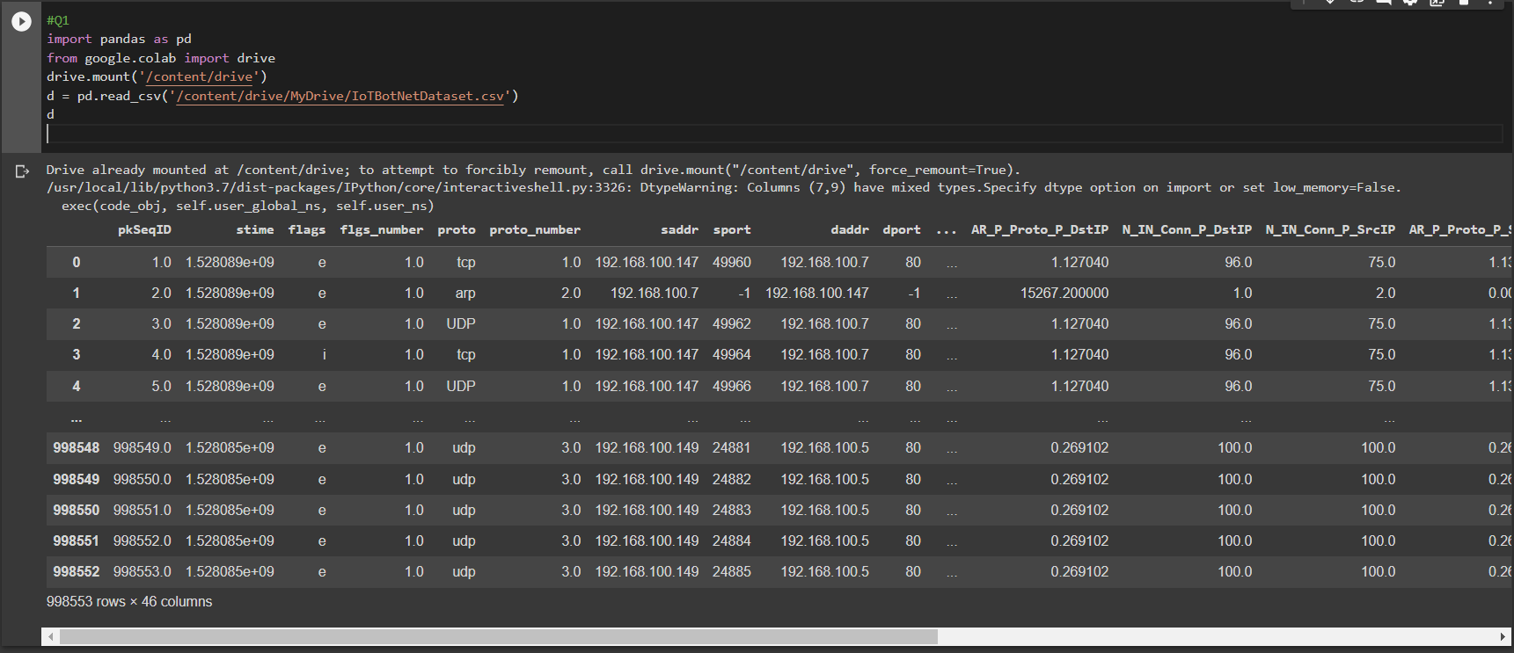

Q2: Drop the columns not required for your analysis.

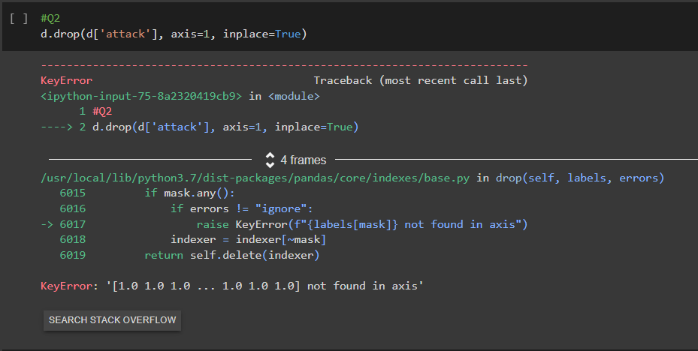

Q3: Do a missing value analysis and perform appropriate steps to correct them.

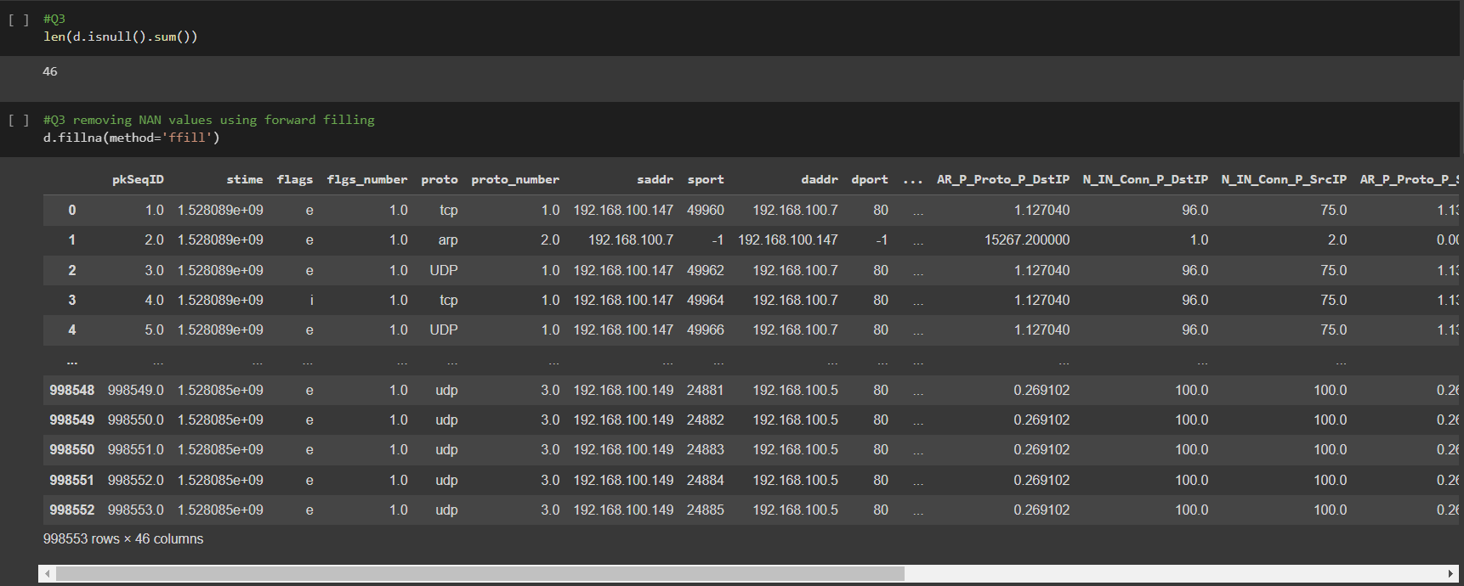

Q5: Do a correlation analysis of any two variables.

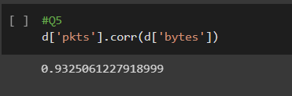

Q6: Describe the data.

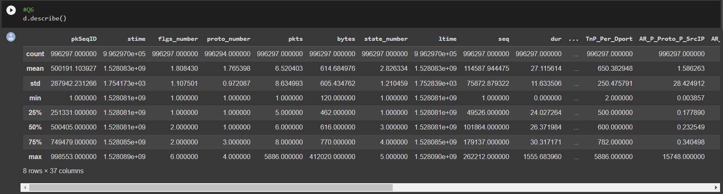

Q7: Display the first 3 rows.

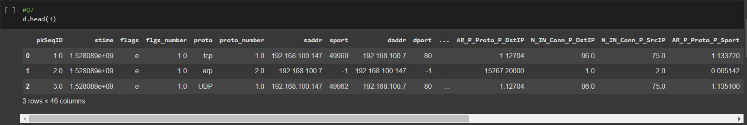

Q8: Display the last 4 rows.

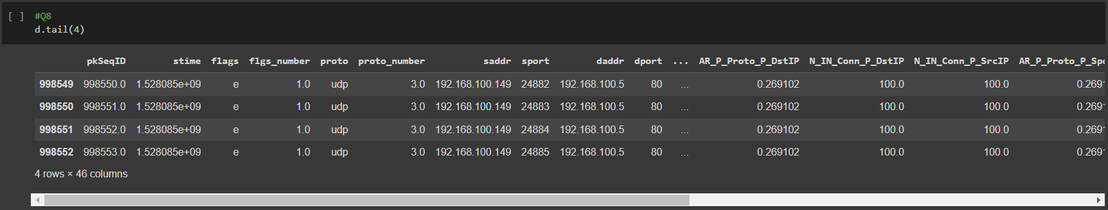

Q9: Locate the first row corresponding to the proto as “UDP”.

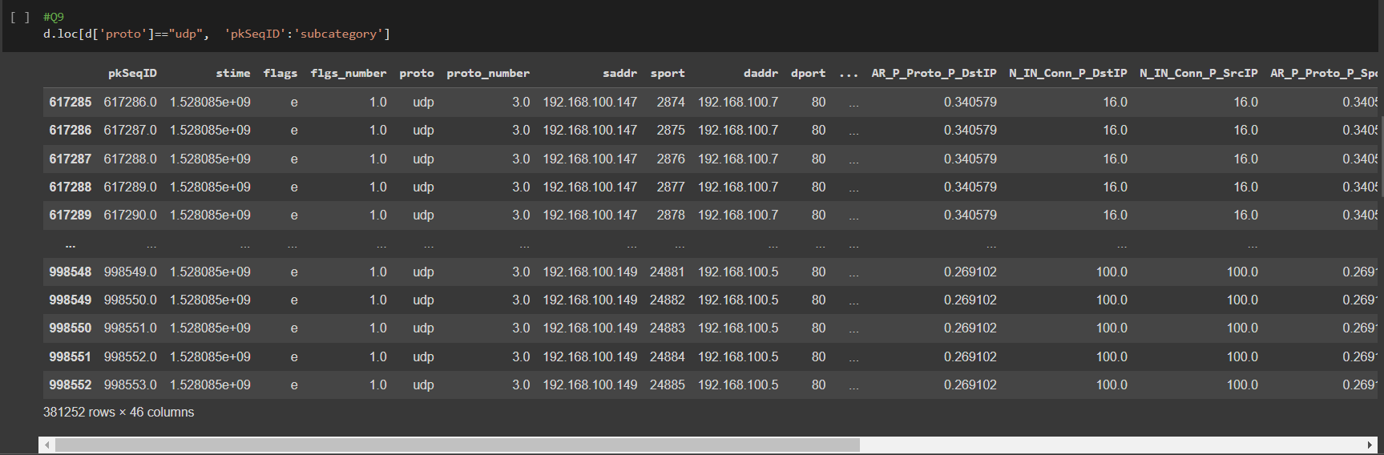

Q10: How many rows of data do you have?

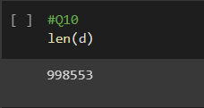

Q11: Display the first 5 columns of the first row.

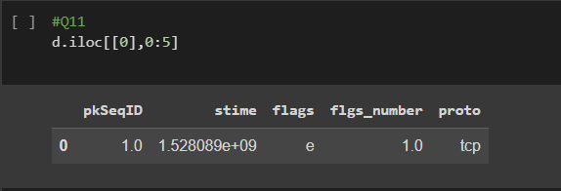

Q12: Count the number of packets affected based on flags as “i”.

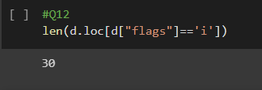

Q13: Split the traffic based on traffic into two groups Group 1: pkts<=10

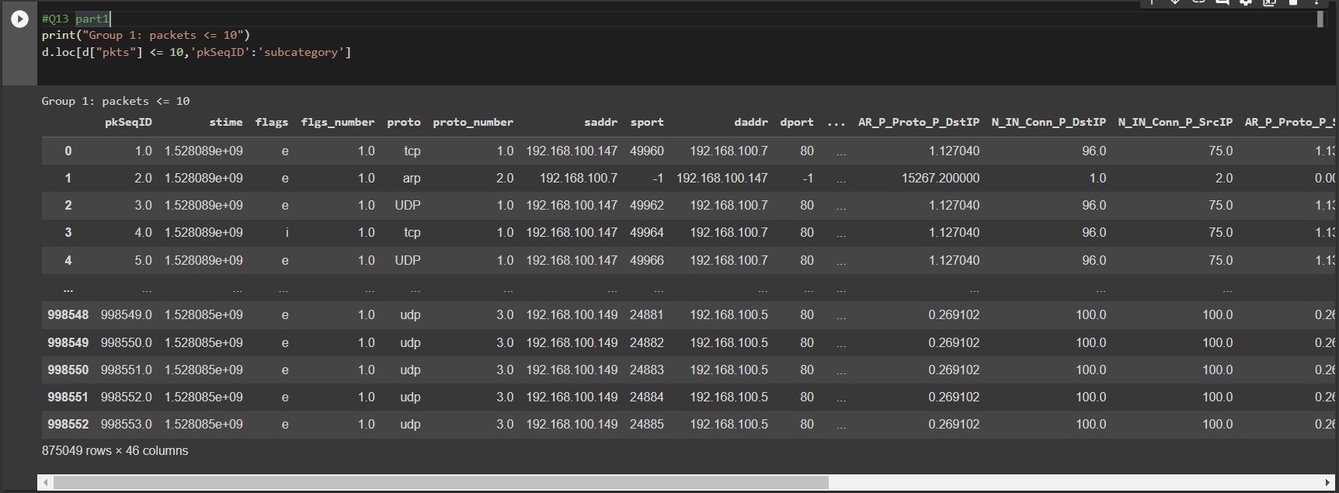

And Group 2: pkts>10.

